Orion User Manual

Original Vision Systems

October 2021

Contents

1. Introduction 4

Welcome to the Orion User Manual 4

What’s covered? 4

2. Contact Information 5

1.1 Introduction 5

1.2 Contact Information 5

1.3 Conclusion 5

3. System Implementation Procedure 6

3.1 Introduction 6

3.2 Hardware and Software requirements 6

3.2.1 Hardware Requirements 6

3.2.2 Software Requirements 6

3.3 Implementation Procedure 6

3.4 Conclusion 6

4. Backup and restore 7

5. Controls 7

5.1 Introduction 7

5.2 General Controls 7

5.3 Conclusion 8

6. Help Function 8

6.1 Introduction 8

6.2 How to get help 8

6.3 Conclusion 8

7. System Functionality 9

7.1 Introduction 9

7.2 System Functionalities 9

1. User Subsystem 9

2. Customer Subsystem 12

3. Employee Subsystem 13

4. Admin Subsystem 17

5. Product Subsystem 21

6. Reporting Subsystem 36

7. Settings Subsystem 40

8.Supplier Subsystem 46

9. Production Subsystem 48

8. Glossary 50

9. Client Sign-off 51

# Introduction

Welcome to the Orion User Manual.

First, we would like to thank you for choosing our product and hope you will have a pleasant experience. This manual contains all the essential information needed for the user to make full use of the program, it contains descriptions of all the system functions and capabilities, contingencies and alternate modes of operation, and step-by-step procedures for system access and use, there is also the use of graphics for ease of use.

## What’s covered?

This manual will cover the following:

* All of the system’s nine subsystems
* Detailed explanation of system functions
* Possible errors in specific system functions
* All general errors that are possible
* How to get help in the system
* Detailed explanation of all screens in the system
* Detailed explanation of all reports generated by the system
* Explanation of the backup and restore procedure
* Explanation of how the on-line HELP function could be activated or used

# Contact Information

## 1.1 Introduction

In this section we provide the contact details for future help with the system. There is an option where you can contact one of the members of Original Vision Systems. Questions may be answered and will be given clarity on any functionalities in the system.

## 1.2 Contact Information

Contact the team if you require any queries, concerns or information about the system.

Simishka Dasupan +27 67 124 4237 [u18031880@tuks.co.za](mailto:u18031880@tuks.co.za)

Bongani Nkomo +27 62 715 7091 [u19232812@tuks.co.za](mailto:u19232812@tuks.co.za)

Pride Mkhabela +27 81 816 9597 [u18073639@tuks.co.za](mailto:u18073639@tuks.co.za)

Chase Nel +27 82 563 8990 [u19054743@tuks.co.za](mailto:u19054743@tuks.co.za)

[Matome Mabitsi](mailto:Matome%20Mabitsi) +27 65 924 9377 [u18216740@tuks.co.za](mailto:u18216740@tuks.co.za)

## 1.3 Conclusion

This section now contains all the contact details of the Open Vision Systems Team members

# System Implementation Procedure

## Introduction

The System Implementation Procedure is described here for the User Manual

## Hardware and Software requirements

### Hardware Requirements

* A mobile Device running iOS/Android operating system
* A laptop/Desktop computer with a compatible browser and operating system Microsoft Windows 10 or later
* Microsoft SQL Server Database
* Note: All device needs an internet connection

### Software Requirements

* 500GB hard drive disk (More with be recommended)
* 4GB RAM (8GB RAM would be recommended)
* Intel Core i5 Processor (2.5Ghz)

## Implementation Procedure

* Orion system is an online system and therefore requires no installation. Once can access the system online by using the following URL: https:// It also requires one to login with valid credentials.
* The sampling system mobile application is an online system and therefore requires no installation.

## Conclusion

The system implementation procedures were described here for the User Manual.

# Backup and restore

This option was not selected on the complexity matrix by the Open Vision System team for their Orion system.

# Controls

## Introduction

The controls of the Orion system are listed and described here for the User Manual.

## General Controls

Main Controls

|  |  |
| --- | --- |
|  | Descriptions |
| Menu Item | The menu item is the list of items displayed on the left-hand side of the screen. This allows quick and easy navigation between pages. When referred to, the name of the specific menu item will be disclosed. Some items have an arrow displayed next to it, which indicates that more pages are available under the item. These can be accessed by clicking on the item. |
| Textbox | Textboxes can be used to enter specific information |
| Dropdown list | Dropdown list contains information stored in the database. They provide more than one option where the user can choose the needed information from. |
| Table | A table displays information stored in the database. The columns in the table can be filtered with the use of the filter functionality. |
| Tabs | Details are displayed on the same screen, just in different tabs. It sections the information begin shown into separate tabs |
| Labels | Labels are disable controls. They are just there to provide information and no changes can be made to them. |

## Conclusion

The controls of the Orion system were listed and described here for the User Manual.

# Help Function

## Introduction

The help functionality of the Orion system is explained and described upon here for the User manual.

## How to get help

## Conclusion

The help functionality of the Orion system was explained and described upon here for the User Manual.

# System Functionality

## Introduction

This section will contain the explanation and display of the systems controls and functionality for the Orion system.

## System Functionalities

### User Subsystem

#### Login

This function requires the user to enter the login details which are: Username and Password. The user enter username and password and after those details have been validated , the user will get access to the Orion System and be directed to different pages depending on the user role

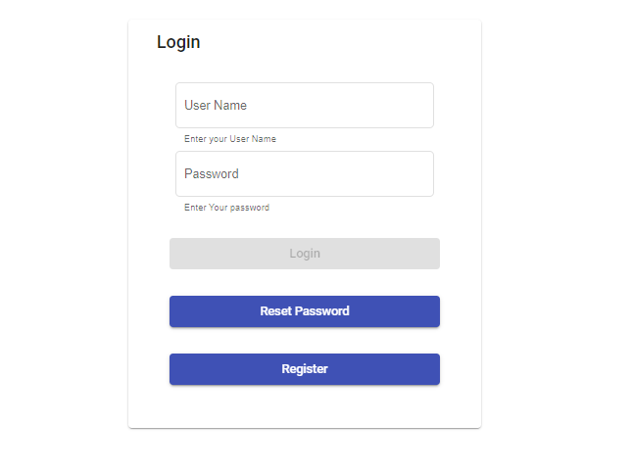

2

3

4

5

1

|  |  |  |
| --- | --- | --- |
| Item number | Item name | functionality |
| 1 | Username textbox | Click here to enter the user’s username. |
| 2 | Password textbox | Click here to enter the user’s password. |
| 3 | Log in button | Click the log in button to be redirect to either Browse Products if the user is a customer and if the user is an employee get directed to an employee page and lastly if the user is a manger get directed to manager home page |
| 4 | Forgot password button | Click the reset password button if you have forgotten the password to be redirected to reset password screen |
| 5 | Register Customer button | Click register button if you want to register as a customer and the OVS system will redirect to Register customer page |

#### Reset Password

#### Logout

 The aim of this function is to log out and return to the login screen. The logout button is located in the hamburger menu item on the top left. The user must click on the menu item. The user must then proceed to click the “Logout” button. The user will then be logged out of the system.

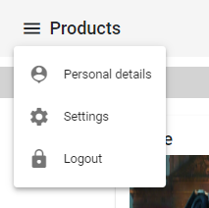

1

|  |  |
| --- | --- |
| Name | Description |
| Logout Button | Clicking this button would log the user out of the system |

### Customer Subsystem

#### Place order

#### Browse products

The function requires the manager to already have added products to the Orion System . The user can click on the Product Category which then product types will be displayed , the customer can then click on the desired product type and products will displayed belonging to that product type

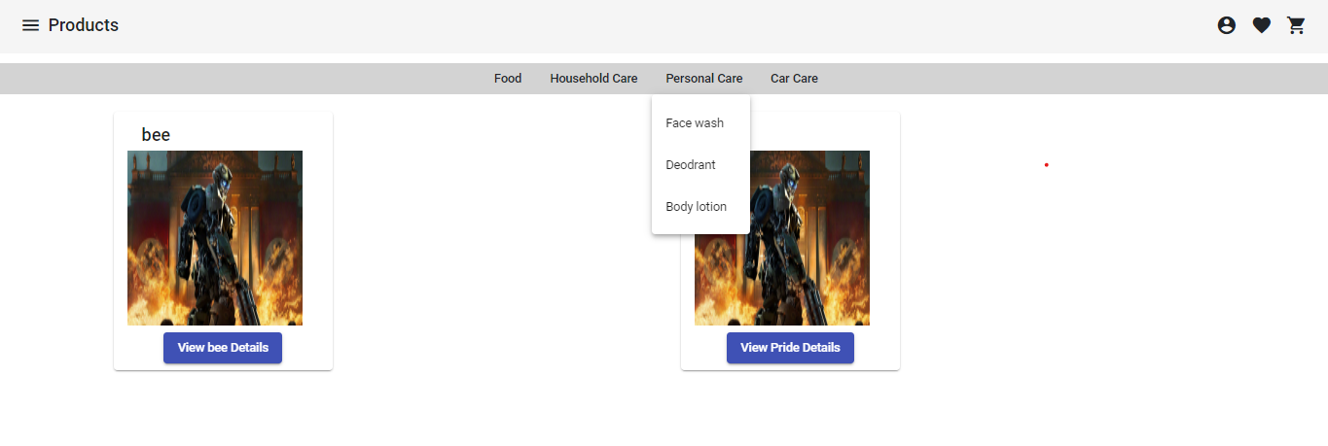

5

1

4

3

2

|  |  |  |
| --- | --- | --- |
| Item number | Item name | functionality |
| 1 | Category button | Click on the category button to display the products type pop with all the product types belonging to that category |
| 2 | Product types pop-up with buttons | Click on the specific product type to filter the products or only display products that fall under that product type |
| 3 | Product Picture | Display product picture |
| 4 | Label : Product Name | Display product name |
| 5 | View Product details button | Click on button the Orion system will navigate the to View Product Details |

#### View Product details

This function will be used to view the details for the products that were added by the manager, the user will click on the product to view the product details.

#### Add to cart

This function will be used to add items the customer wants to order to the cart, the customer has to view the products they want before they can add them to cart.

#### View Cart

#### Remove item from Cart

#### Empty Cart

#### Checkout

#### Make payment

#### Return Order

#### Add to Wishlist

#### View Wishlist item

#### Remove Wishlist item

#### Search order

#### View Order

#### Track Order

### 3. Employee Subsystem

#### Book Shift

The purpose of this function is to allow an employee to reserve a selected slot on the shifts schedule

|  |  |  |
| --- | --- | --- |
| Item number | Item name | Functionality |
| 1 | Shift Details Card | Details on the shift |
| 2 | Book shift button | Clicks on the Book shift button to reserve the slot as well as employee details on the Orion system |
| 3 | Cancel button | Click to cancel the operation |

#### Search Customer

The purpose of this function is to display a customer’s details from the customer records saved within the Orion system. The results will be displayed in a table

#### Edit Customer

The purpose of this function is to change or update a customer’s details then save the changes to the orion system

#### Add customer

This function describes when the customer wants to register himself/herself on the Orion System in order to get all the functionality as a customer, such as placing an order, view previous orders.

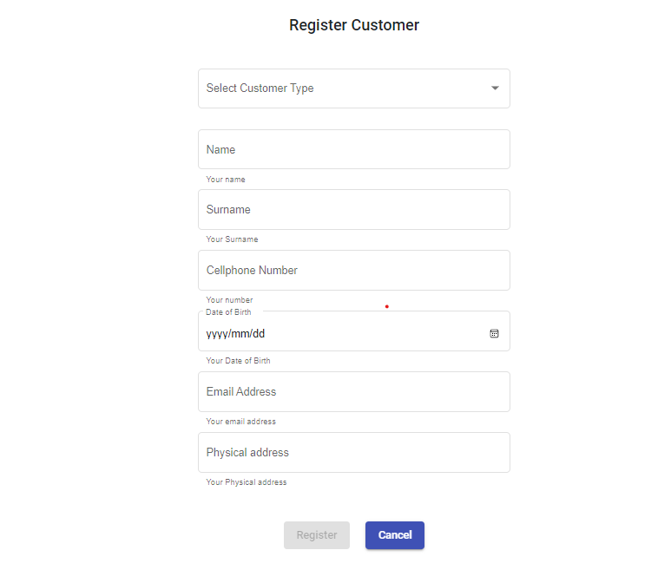

9

8

7

6

5

4

3

2

1

|  |  |  |
| --- | --- | --- |
| Item number | Item name | Functionality |
| 1 | Customer type dropdown | Select a customer type |
| 2 | Customer Name Textbox | Enable customer to enter name |
| 3 | Customer Surname Textbox | Enable customer to enter surname |
| 4 | Customer Cellphone Textbox | Enable customer to enter cellphone |
| 5 | Customer date picker | Enable customer to pick date of birth of birth |
| 6 | Customer email address | Enable customer to enter email address |
| 7 | Customer Physical address textbox | Enable customer to enter physical address |
| 8 | Save Button | Click on save button for Orion system to save customer details and naviage user to add user page |
| 9 | Cancel button | Click on Cancel button for Orion System to navigate to Log in page |

#### Search sale

The purpose of this function is to display results of existing sales from user given criteria, the results will be displayed in a table

#### Assign credit note

The purpose of this function is to give credit to a customer who has return goods on a sale or order

#### Search Quotation

The purpose of this function is to display results of existing quotes from user given criteria, the results will be displayed in a table

#### Accept/Reject Quotation

The purpose of this function is to notify the system of whether a requested quote has been approved by the customer so it can be processed as a sale or whether the customer has not given approval or rejected the.

#### Make Quotation

The purpose of this function is to create a quote of requested items from a customer, this document is printable

#### View for delivery

The purpose of this function is to view all the orders which the order status “Packed’

#### Pack Order

The purpose of this function is to selected placed order and view the item/s to be packed. The order status is then changed from ‘Placed’ to ‘Packed’

#### Assign order to delivery

The purpose of this function is to assign order with the ‘Packed’ order status to a driver to deliver them

#### Complete Delivery

The purpose of this function is to allow a driver to indicate that he/she has completed a delivery so it may be saved/ updated on the system

### 4. Admin Subsystem

#### Add user

This function describes when the manager / customer wants to add user on the Orion System. The user has to enter username and password which will be saved on the system to enable the user to access the system

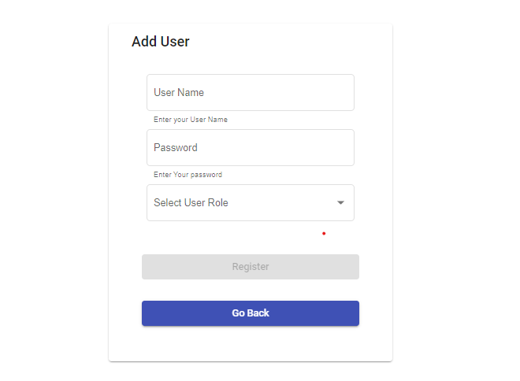

5

4

3

2

1

|  |  |  |
| --- | --- | --- |
| Item number | Item name | Functionality |
| 1 | Username textbox | Click to enter username |
| 2 | Userpassword textbox | Click to enter userpassword |
| 3 | Select User role drop down | Click to select the user roles |
| 4 | Register button | Clicks on the register button to save user details on the Orion system |
| 5 | Go Back button | Clicks on the Go Back button to navigate back |

#### Search user

This function is when the manager wants to view the users in the system. The system will display the users in a table with the following

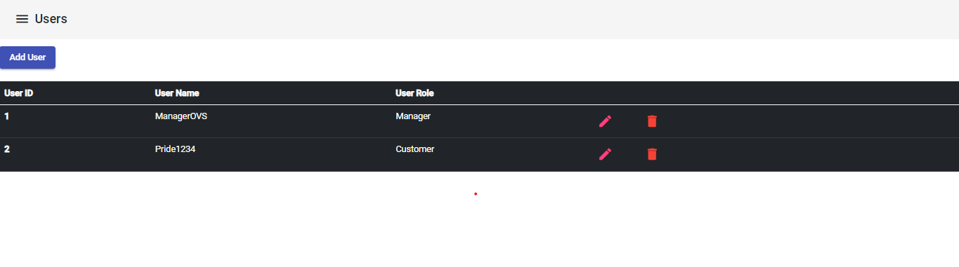

2

6

5

4

3

1

|  |  |  |
| --- | --- | --- |
| Item number | Item name | Functionality |
| 1 | Add user button | Click on the add user button to navigate to the add user page |
| 2 | User ID Column header | Display the number of users |
| 3 | Username column header | Display the usernames |
| 4 | User Role | Display the user role names |
| 5 | Edit icon | Click on the edit icon button to navigate to the edit page for the user |
| 6 | Delete icon | Click on the delete icon button to delete the selected user , the Orion system will refresh the page |

#### Remove user

The purpose of this function is to delete a user record from the system. This function is only available for managers

#### Edit user

This function is when the manager or even the customer wants to edit user details. This happens after the edit icon has been clicked

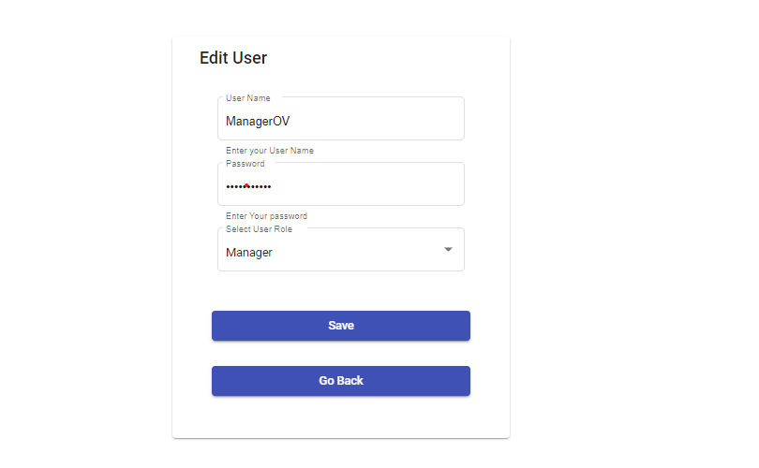

2

3

4

5

1

|  |  |  |
| --- | --- | --- |
| Item number | Item name | Functionality |
| 1 | Username textbox | Click to edit username |
| 2 | Userpassword textbox | Click to edit user password |
| 3 | Select User role drop down | Click to select the user roles |
| 4 | Register button | Clicks on the register button to save user details on the Orion system |
| 5 | Go Back button | Clicks on the Go Back button to navigate back |

#### Open cash register

The purpose of this function is to allow the system to open the cash register

#### Close cash register

The purpose of this function is to have the user close the register

#### Define user permission/ access rights

The purpose of this function is to allow the manager to define the levels of access or restriction users have

#### Search shift

The purpose of this function is to display results of existing shifts from user given criteria,

#### Add shift

#### Edit Shift

#### Remove shift

### 5. Product Subsystem

#### Search product

The purpose of this function is to display all the products which have already been added on the Orion System.

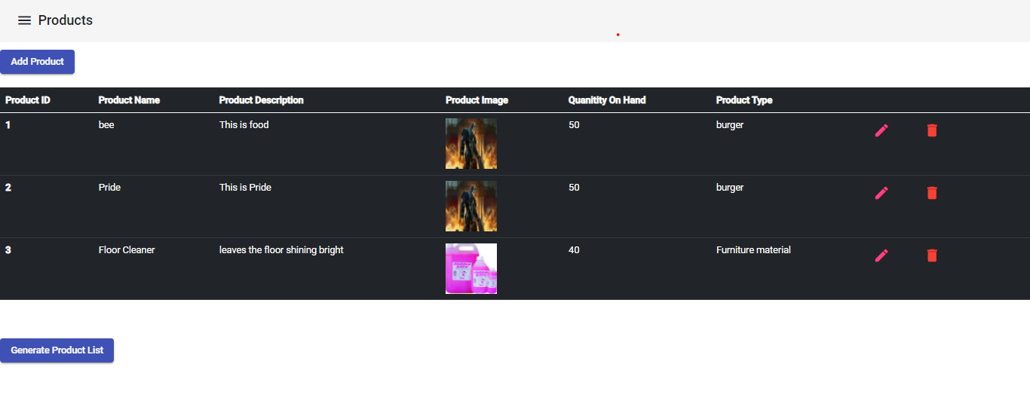

9

8

7

6

5

4

3

2

1

|  |  |  |
| --- | --- | --- |
| Item number | Item name | Functionality |
| 1 | Add Product Button | Click to navigate to an add product page |
| 2 | Product ID column header | Specify all the products numbers below |
| 3 | Product Name column header | Specify the product names  below |
| 4 | Product Image column header | Specify the product images below |
| 5 | Quantity on hand column header | Specify the product's quantity on hand |
| 6 | Product Type column header | Specify the product types below |
| 7 | Edit Icon (button) | Click the edit icon button to navigate to the edit product page |
| 8 | Delete icon(button) | Click the delete icon button to delete the product and refresh the page |
| 9 | Generate Product List | Click to print list of available products |

#### Add product

The purpose of this function is to add a product to the Orion system. When adding a product the product type has to be selected in order to add that product to that product type.

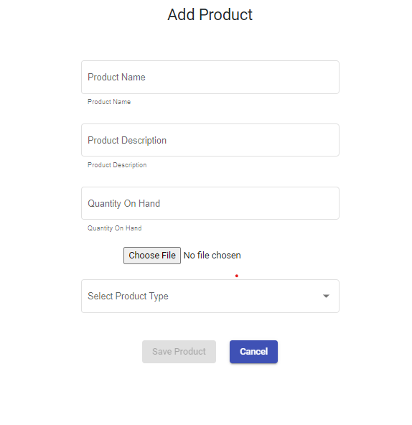

2

3

4

5

6

7

1

|  |  |  |
| --- | --- | --- |
| Item number | Item name | Functionality |
| 1 | Product name textbox | Click to enter the product name |
| 2 | Product description textbox | Click to enter product descriptions |
| 3 | Quantity on hand textbox | Click to enter the product quantity on hand |
| 4 | File input | Click to select product picture |
| 5 | Product type drop down select | Click to select product type |
| 6 | Save Product | Save to system |
| 7 | Cancel | Cancel operation |

#### Edit product

The purpose of this function is to edit the product details. The Orion system will retrieve the product information that can be edited and save the changes to the product details.

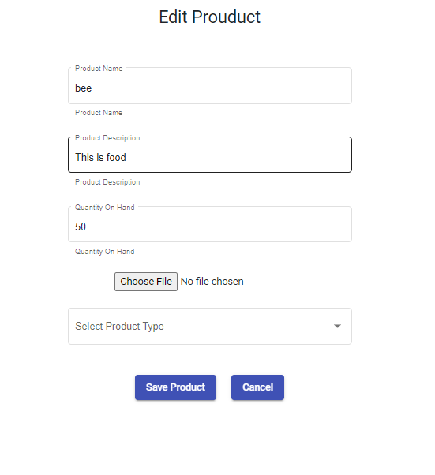

7

6

5

4

3

2

1

|  |  |  |
| --- | --- | --- |
| Item number | Item name | Functionality |
| 1 | Product name textbox | Click to edit the product name |
| 2 | Product description textbox | Click to edit the product descriptions |
| 3 | Quantity on hand textbox | Click to edit the product quantity on hand |
| 4 | File input | Click to select product picture |
| 5 | Product type drop down select | Click to select product type |
| 6 | Save Product | Save to system |
| 7 | Cancel | Cancel operation |

#### Delete product

#### Manufacture/Package product

#### Do stock take

#### Transfer stock

#### Search product type

The purpose of the function is to display the product types from the Orion system.

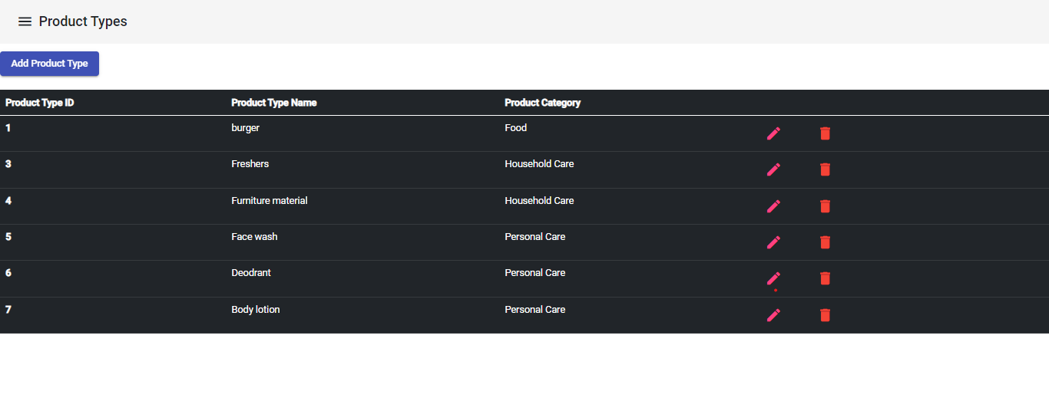

3

6

5

4

2

1

|  |  |  |
| --- | --- | --- |
| Item number | Item name | Functionality |
| 1 | Add Product Type Button | Clicks on the add product type button to navigate to the add product type page |
| 2 | Product type id column header | Display the number of product types |
| 3 | Product type name column header | Display the product type names |
| 4 | Product Category Column Header | Display the product Category names |
| 5 | Edit ( pencil) icon | Click on the edit icon to navigate to the edit product type page |
| 6 | Delete icon | Cick on the delete icon to delete |

#### Add Product type

The purpose of this function is to add product type to the OVS system. The manager has to select the product category , then click the text box with enter product type to be added within that product category. Click Save Button to save the Product Type

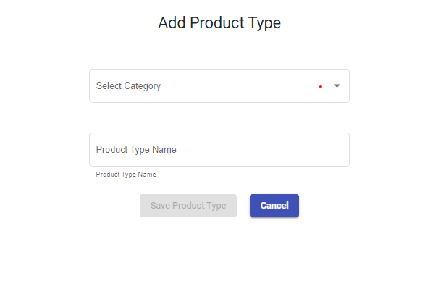

4

3

2

1

|  |  |  |
| --- | --- | --- |
| Item number | Item name | Functionality |
| 1 | Select Product Type drop down | Click drop down to select the Product Category |
| 2 | Product Type Textbox | Click textbox to enter product type |
| 3 | Save Product Type button | Click on the save product type button to save the product type. Button is enabled after a product category is selected and product type has been entered |
| 4 | Cancel button | Click cancel button to navigate to the view product types page |

#### Edit product type

The purpose of this function is to enable the manager to edit the product type. The manager will have to select the product category and then edit the text on the product type ,then click the save product type button to save changes.

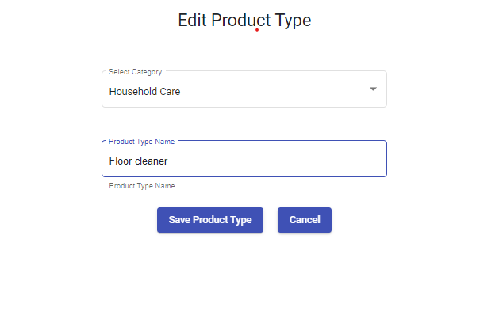

3

4

2

1

|  |  |  |
| --- | --- | --- |
| Item number | Item name | Functionality |
| 1 | Select Product Type drop down | Click drop down to select the Product Category |
| 2 | Product Type Textbox | Click textbox to enter  updated product type name |
| 3 | Save Product Type button | Click on the save product type button to save the product type. Button is enabled after a product category is selected and product type has been updated |
| 4 | Cancel button | Click the cancel button to navigate to the view product types page |

#### Remove product type

#### Search product category

The purpose of this function is to display all the product categories in a table. The product categories can be edited by clicking on the pencil icon which will navigate the manager to the edit Product Category page and can also delete the product category by clicking on the bin/trash icon

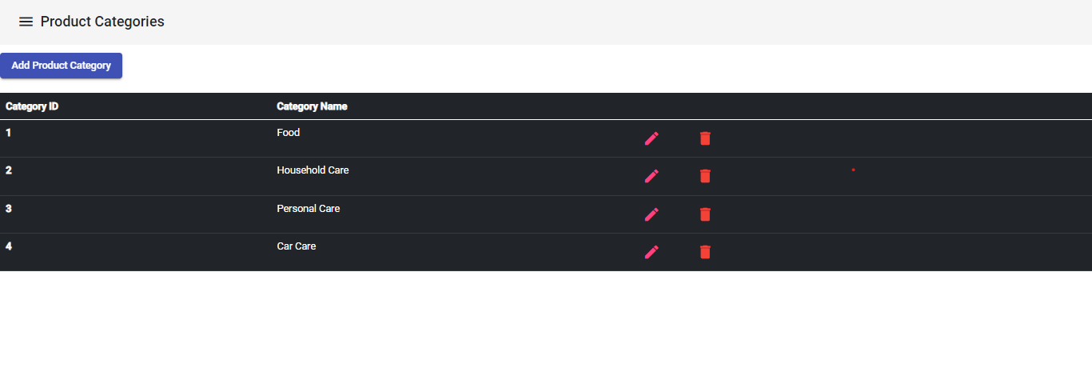

5

4

3

2

1

|  |  |  |
| --- | --- | --- |
| Item number | Item name | Functionality |
| 1 | Add Product Category button | Click the add product category button |
| 2 | Product Category ID column header | To show column rows for all the product IDs |
| 3 | Product Category Name | To show the column rows with all the product category names |
| 4 | Pencil icon ( button) | Click on the pencil icon button to navigate to the edit product category page |
| 5 | Trash/bin icon (button) | Click on the trash/bin icon button to delete the product category |

#### Add product category

The purpose of this function is to add product categories to the Orion System . The system will display the following Add product Page

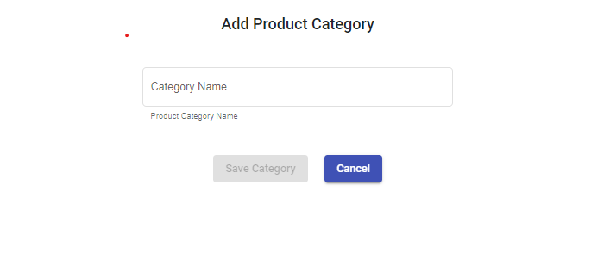

3

2

1

|  |  |  |
| --- | --- | --- |
| Item number | Item name | Functionality |
| 1 | Product Category Textbox | Click on the Category text box to enter a new product category |
| 2 | Save Category button | Button is enabled after a product category has been entered on the textbox. Click on the button to save |
| 3 | Cancel Button | Click button to navigate back to manager back |

#### Edit product category

The purpose of this function is to allow manager to update the product category.The manager will enter the updated product category then click save to save the changes

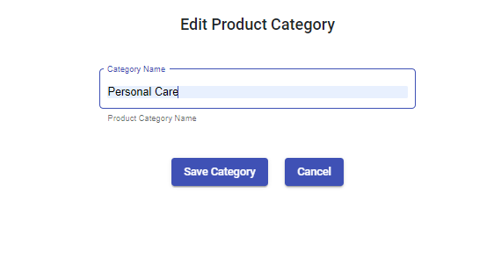

2

3

1

|  |  |  |
| --- | --- | --- |
| Item number | Item name | Functionality |
| 1 | Product Category Textbox | Click on the Category text box to enter the updated product category name |
| 2 | Save Category button | Button is enabled after a product category has been entered on the textbox. Click on the button to save |
| 3 | Cancel Button | Click button to navigate back to manager back |

#### Remove product category

#### Search raw material

The purpose of this function is to allow the manager to view all the raw materials on the Orion System

#### Add raw material

This function allow the manager to add raw material to the Orion system .Which can be used to produce new products

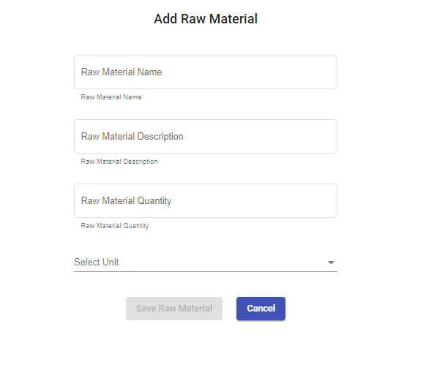

|  |  |  |
| --- | --- | --- |
| Item number | Item name | Functionality |
|  | Raw material name textbox | Click to enter new raw material name |
|  | Raw material description textbox | Click to enter raw material description |
|  | Raw material quantity numeric up down | Click to select/enter raw material quantity |
|  | Select unit drop down | Click to select unit for the raw material |
|  | Save Raw Material button | Click save button after the raw materials details has been entered to save to the Orion System |
|  | Cancel | Click to navigate to back to view all the raw materials |

#### Edit raw material

The purpose of this function is to allow the manager to edit the raw material. Raw material will be saved after the details have been updated

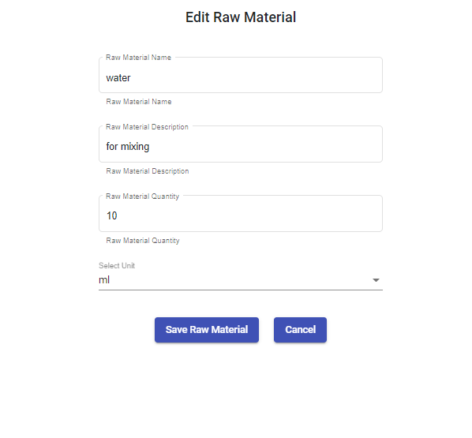

|  |  |  |
| --- | --- | --- |
| Item number | Item name | Functionality |
|  | Raw material name textbox | Click to enter the updated raw material name |
|  | Raw material description textbox | Click to enter the updated raw material description |
|  | Raw material quantity numeric up down | Click to select/enter the updated  raw material quantity |
|  | Select unit drop down | Click to select the updated unit for the raw material |
|  | Save Raw Material button | Click save button after the raw materials details has been updated to save to the Orion System |
|  | Cancel | Click to navigate to back to view all the raw materials |

#### Remove raw material

### 6. Reporting Subsystem

#### Generate weekly sales report

The purpose of this function is to create/generate a sales report which will capture all sales that were made from the company during the week entered. The function will then produce a report where the user will be able to view and download it

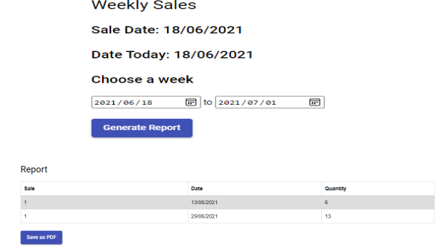

|  |  |  |
| --- | --- | --- |
| Item number | Item name | Functionality |
| 1 | Weekly Sales label | The heading of the function to describe what will happen |
| 2 | Sale Date Label | A label to describe the date to which the sale was made |
| 3 | Date Today label | A label to describe the current date. |
| 4 | Choose a Week Label | A label to guide the user to choose the starting date. |
| 5 | Date picker for starting date | An input device that allows the user to choose a starting date. |
| 6 | Date Picker for ending date | An input device that allows the user to choose a ending date. |
| 7 | Generate Report button | A button used to generate the final weekly report, |
|  |  |  |
| 8 | Report label heading | A label to describe the report |
| 9 | A table with headings of Sale, Date and Quantity | A table that is used to describe the sales report that happened in the week entered in the date pickers. |
| 10 | Save to PDF button | A button used to generate a PDF of the report. |

#### Generate monthly sales report

The purpose of this function is to a sales report which will capture all sales that were made from the company during the Month entered. The function will then produce a report where the user will be able to view and download it.

|  |  |  |
| --- | --- | --- |
| Item number | Item name | Functionality |
| 1 | Monthly Sales label | The heading of the function to describe what will happen |
| 2 | Month Label | A label to describe the month to which the sale was made |
| 3 | Date Today label | A label to describe the current date. |
| 4 | Choose a Week Label | A label to guide the user to choose the starting date. |
| 5 | Date picker for starting date | An input device that allows the user to choose a starting date. |
| 6 | Date Picker for ending date | An input device that allows the user to choose a ending date. |
| 7 | Generate Report button | A button used to generate the final weekly report, |
|  |  |  |
| 8 | Report label heading | A label to describe the report |
| 9 | A table with headings of Sale, Date and Quantity | A table that is used to describe the sales report that happened in the week entered in the date pickers. |
| 10 | Save to PDF button | A button used to generate a PDF of the report. |

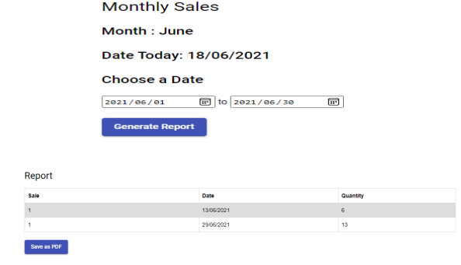

#### Generate product list

This purpose of the function is to generate a list of products that a branch has/will sell.

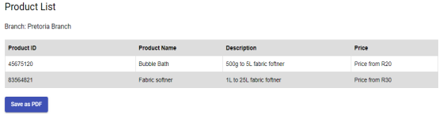



|  |  |  |
| --- | --- | --- |
| Item number | Item name | Functionality |
| 1 | Product List heading | A heading for the product lsit |
| 2 | Branch label | A label that describes which branch we are generating the report from. |
| 3 | Product Table | A table with the columns of Product ID, Product Name, Description and Price, this table is used to capture all the products in a branch. |
| 4 | Save as PDF button | A button used to generate a PDF of the report. |

### 7. Settings Subsystem

#### Add discount

The purpose of this function is to add a record of discount that would then apply to future sales

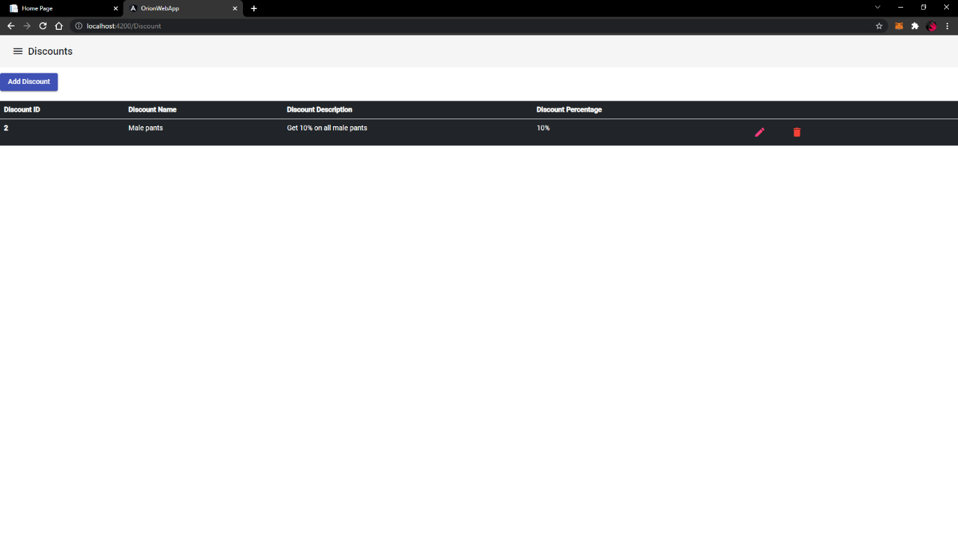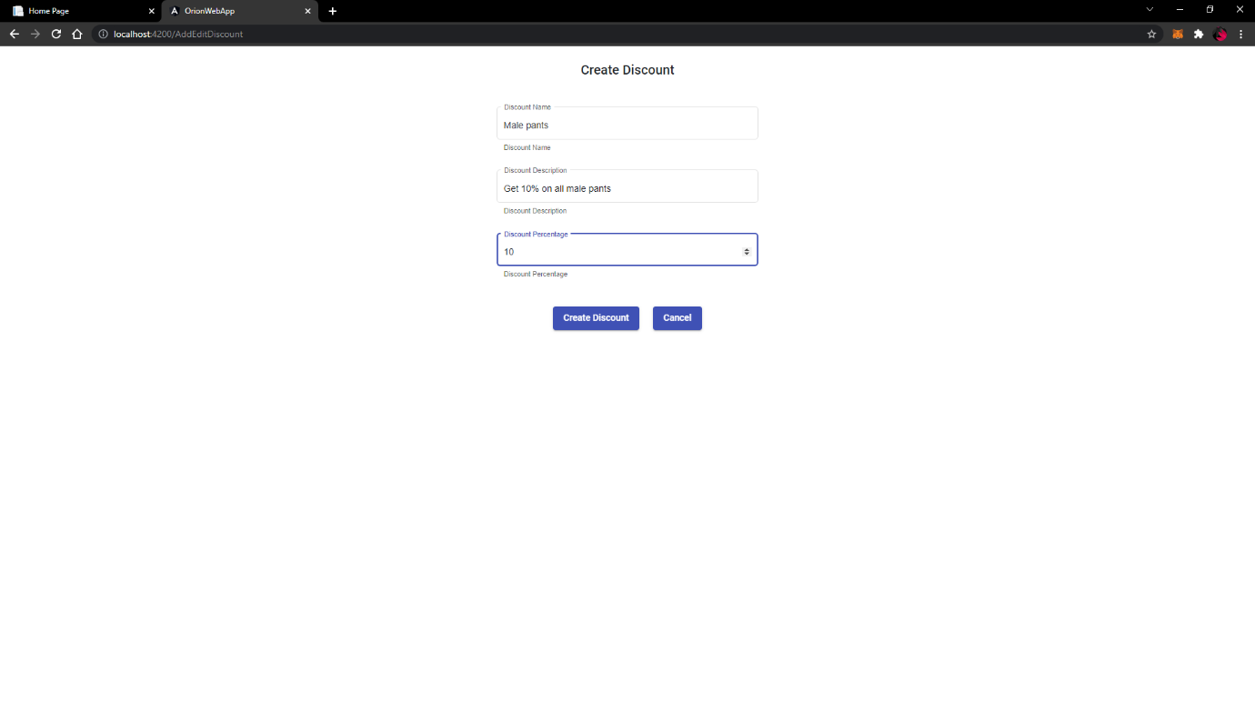

#### Edit discount

The purpose of this function is to edit the records of discount that are saved on the system

#### Add branch

The purpose of this function is to add the new operating branch to the system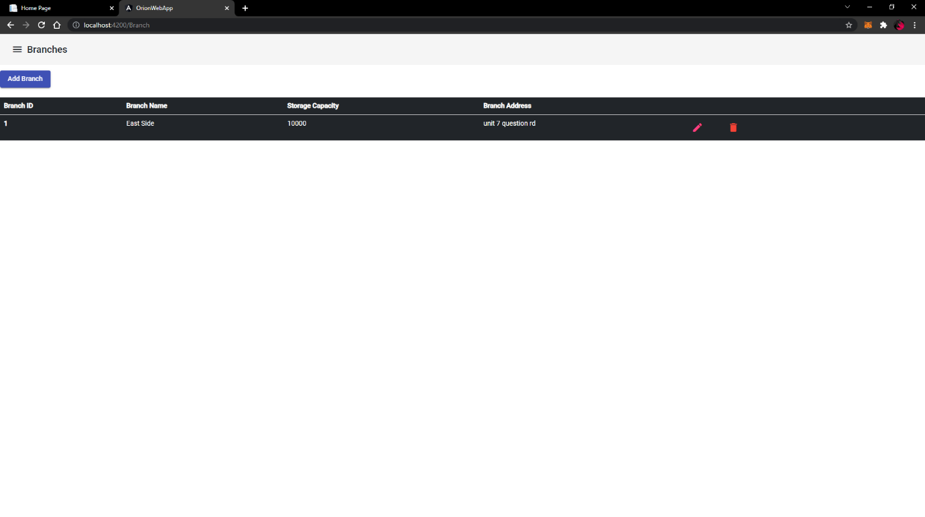

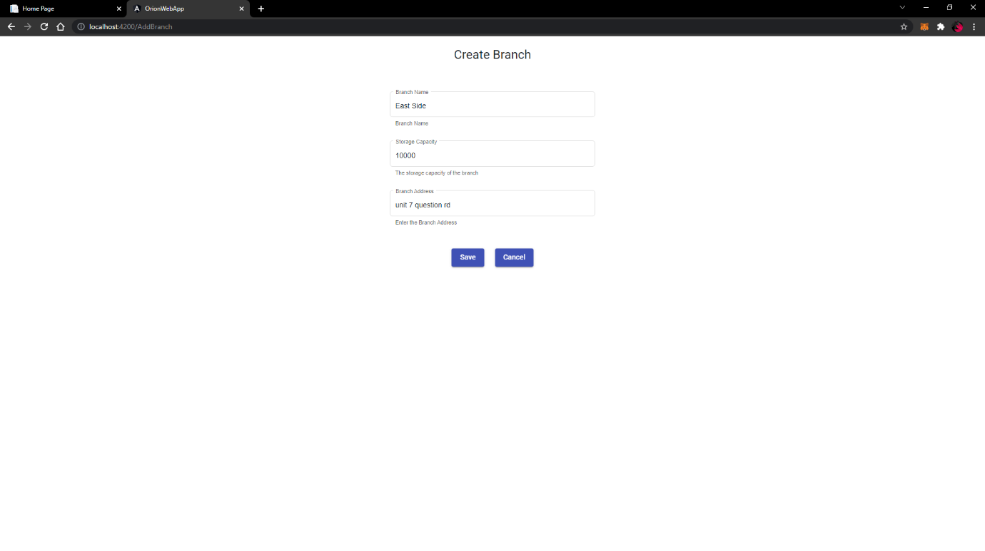

#### Edit branch

The purpose of this function is to change/update an existing branch in the system

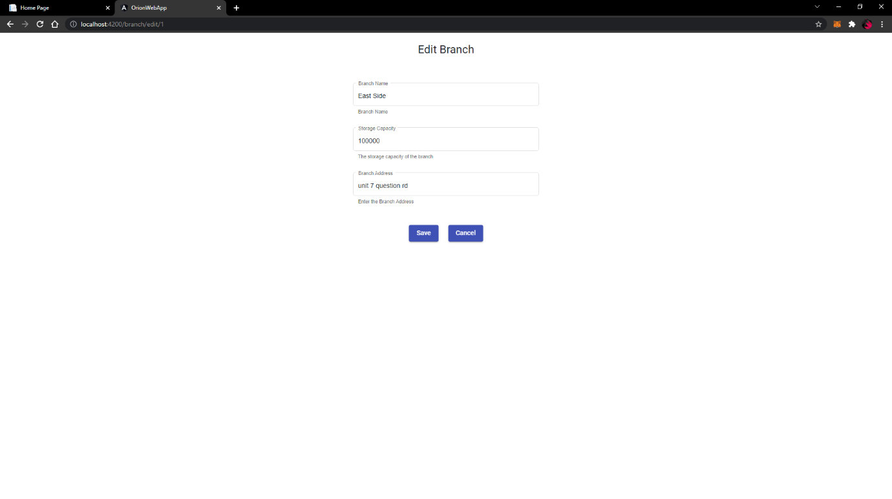

#### Remove branch

The purpose of this function is to delete the record of an existing branch

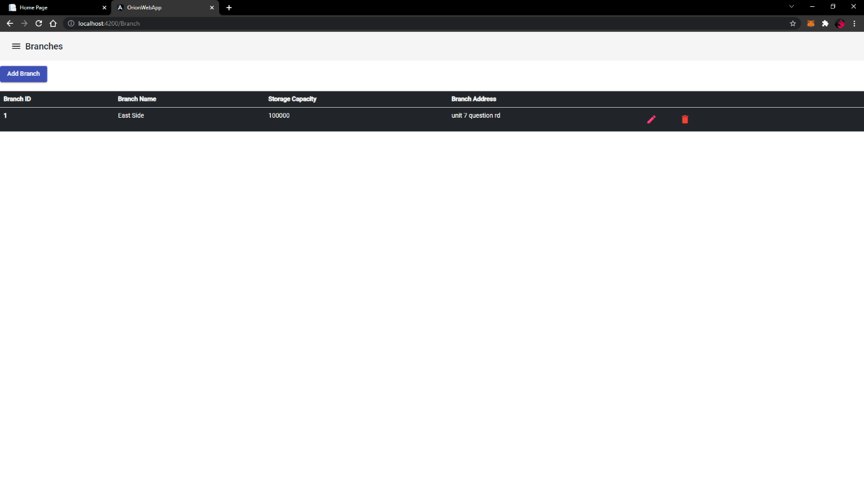

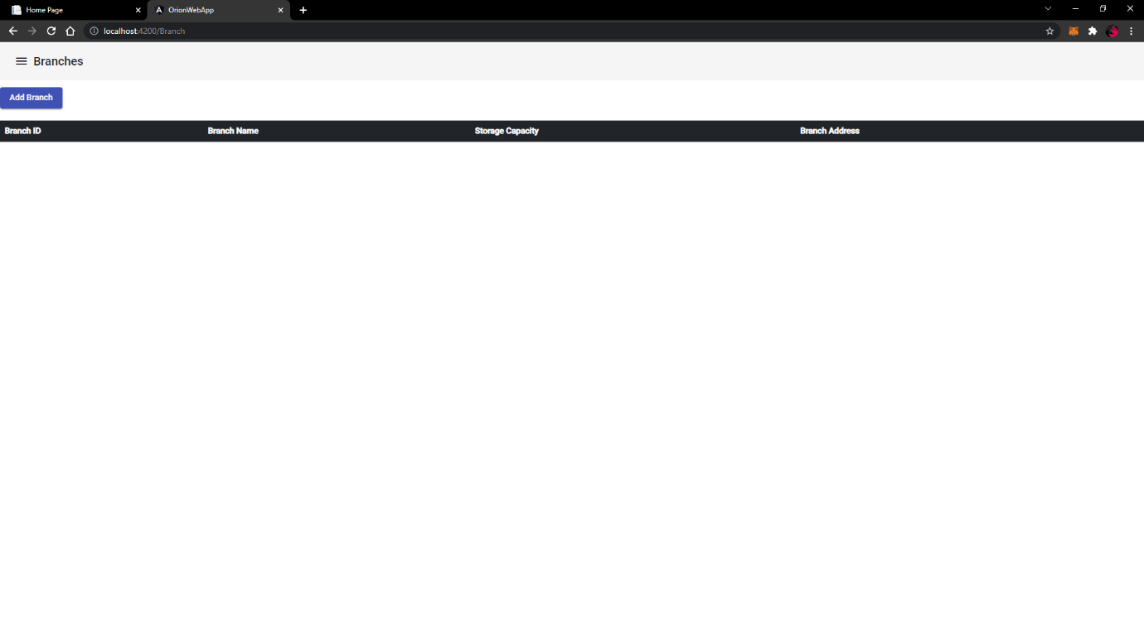

#### Add payment type

#### Edit payment type

#### Delete Payment type

#### Add registers

#### Edit registers

#### Remove registers

#### Add VAT rate

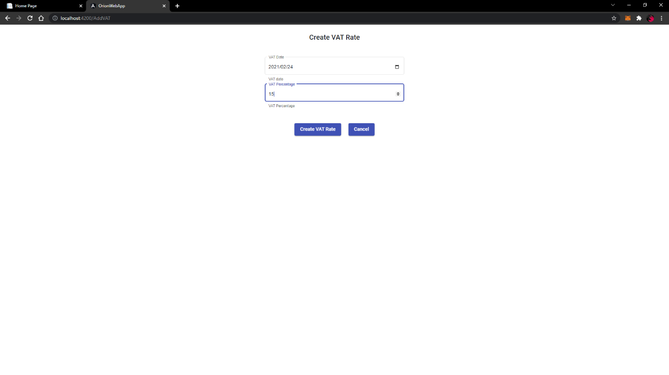

#### Edit VAT rate

#### Remove VAT rate

#### Search Branch

#### Search Payment Type

### 8.Supplier Subsystem

#### Add supplier

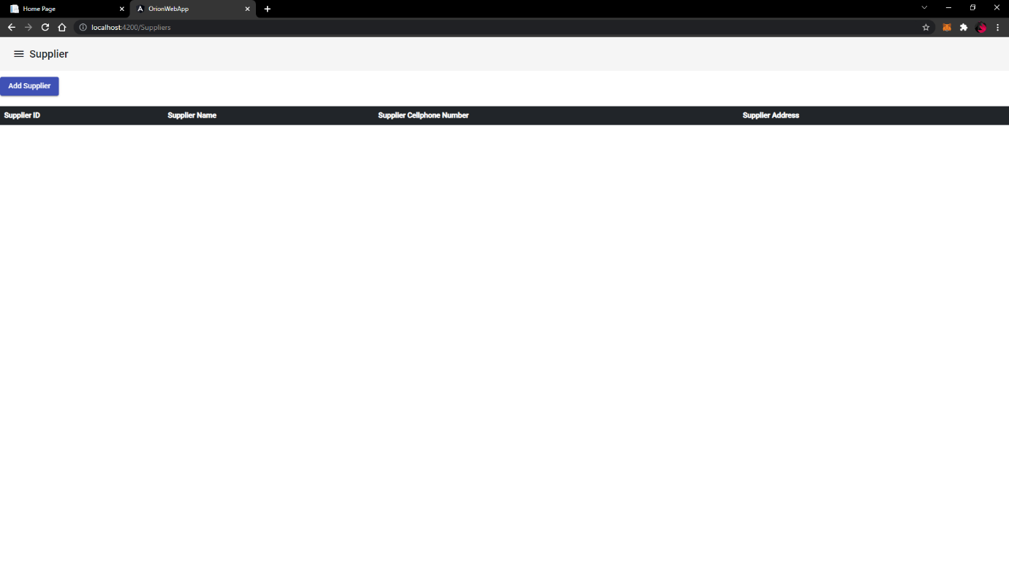

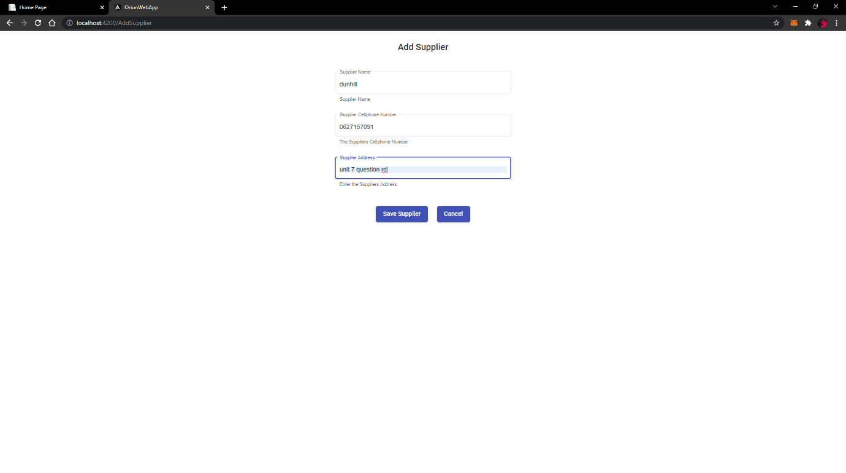

#### Edit supplier

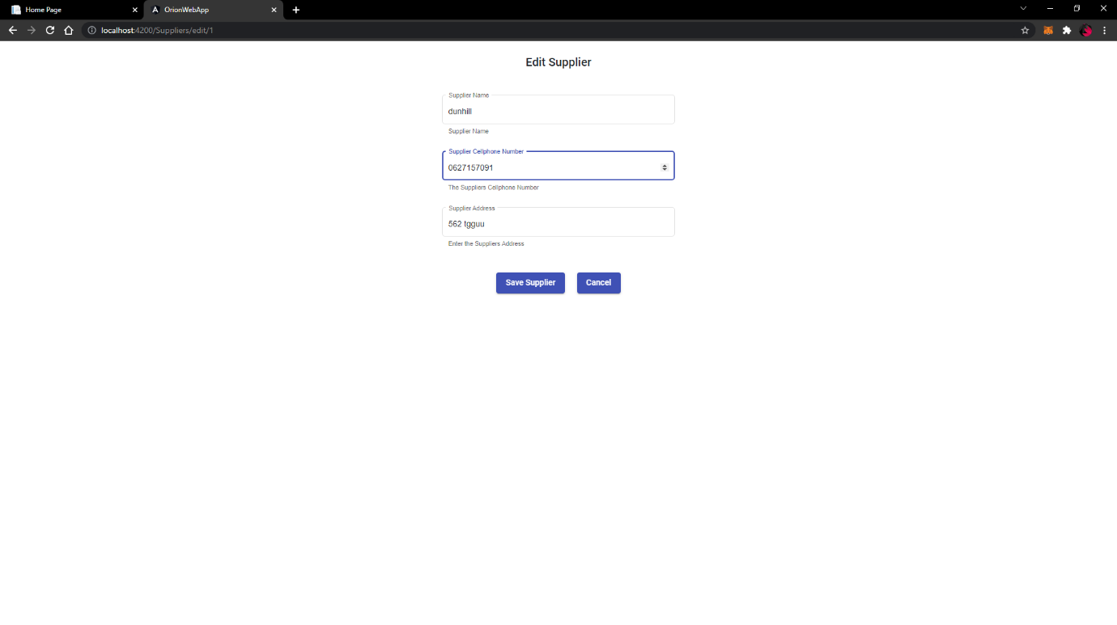

#### Search supplier

#### Place supplier order

#### Search supplier order

#### Cancel supplier order

#### Return supplier order

#### Update supplier order

#### Receive Supplier order

#### Place back order

### 9. Production Subsystem

#### Create Recipe

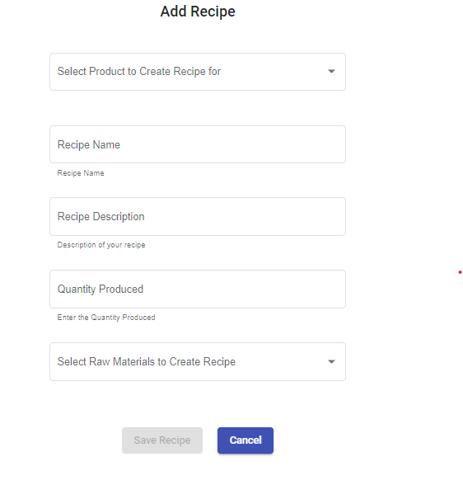

#### Search Recipe

#### Update Recipe

#### Delete Recipe

#### Create Job

#### Edit job

#### Remove job

#### Search job

#### Start job

#### Finish job

# Glossary

A

Android, 6

C

Controls, 7

D

Dropdown list, 7

H

Hardware, 6

I

iOS, 6

M

Menu Item, 7

O

Orion system, 6

R

RAM, 6

S

Software, 6

system, 6

T

Table, 7, 40

Tabs, 8

Textbox, 7

U

User Manual, 7

# Client Sign-off

**This document states that a client signs to validate that s/he has read your materials and is in complete agreement with what you are doing for the deliverable mentioned below**

Dear Client,

Many hours of learning, planning, practice, coding and execution go into being able to look at a company’s current system and create a new system that depicts its quality, efficiency, effectiveness, and most importantly future direction. We do hope that you enjoy looking through our approach and what we have come up with based on what we were given from our requirements. All that is required, is that you review our approach, content and execution of Deliverable 8 and 9. Please call or email any team member mentioned above with any changes/alterations, questions or content concerns that you have during your review. When you completely agree with our approach, please sign the documentation below.

­­­­­­­­­­­

This sign-off formally states that:

I, Suniel Harangee …….

from BRH Chemicals ………

Approval Signature:

I have reviewed the Deliverable 8 and 9 content, understood the approach, and agrees with the content presented by the University of Pretoria students namely Simishka Dasupan, Bongani Nkomo, Pride Mkhabela, Chase Nel and Matome Mabitsi. I believe that, with my changes (discussed), the system is done according to the requirements given to the students, it is technically accurate and complete. I hereby give you approval to proceed with closing deliverable 8 and 9 as complete.

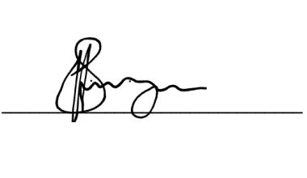

17-10-2021

Date

Signature